What is DOM and How it is represent the HTML structure?
DOM (Document Object Model) is a tree-like representation of an HTML document created by the browser.
It allows JavaScript to access and modify HTML elements.
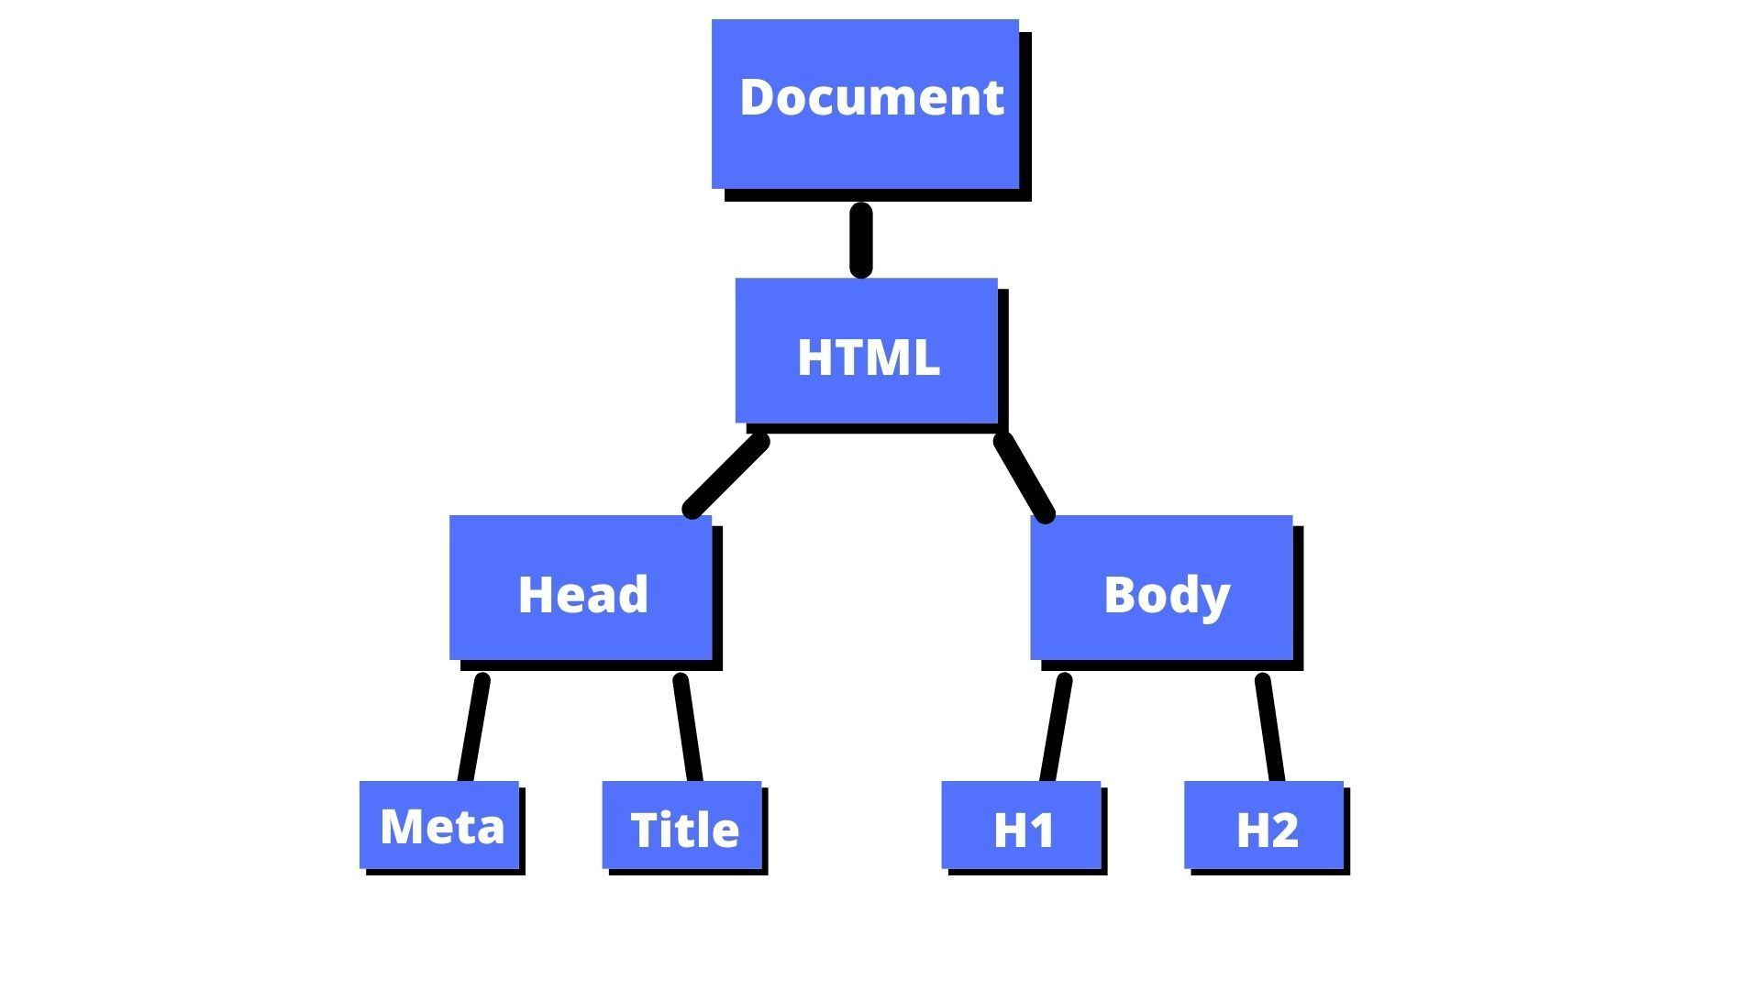

Name types of nodes in DOM

In the JavaScript Document Object Model (DOM), there are 12 distinct types of nodes that inherit from the core Node Interface on MDN Web APIs. Each node type is represented by a specific integer constant.
Types of Nodes in DOM
- Document Node → Represents the whole HTML document.
- Element Node → Represents HTML elements like <div>, <p>, <h1>.
- Text Node → Represents text inside elements.
- Attribute Node → Represents attributes like id, class, src.
- Comment Node → Represents HTML comments <!-- comment -->.
Most important: Document, Element, and Text nodes.
